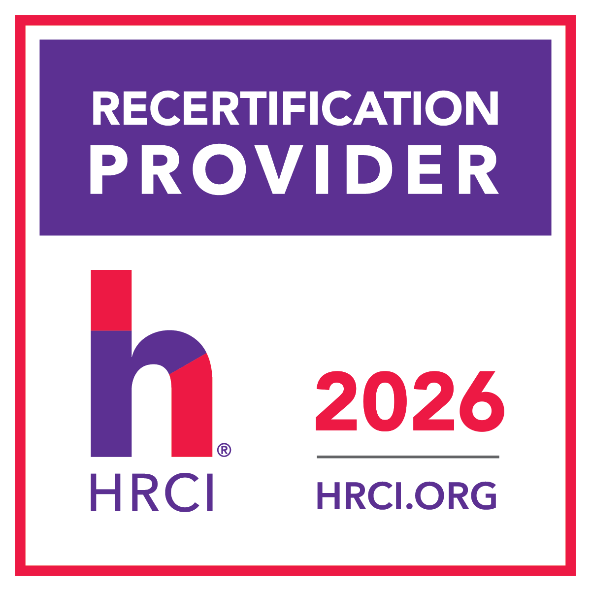
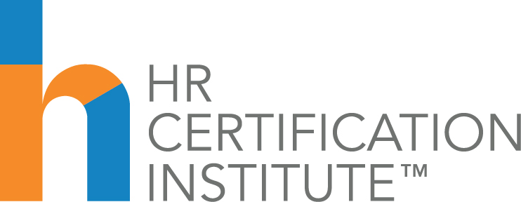

RECERTIFICATION CREDIT FORM

2026 KS SHRM Diversity Series
Webinar | March 26, 2026

Grief in the Workplace: Beyond “I AM SORRY”

The use of this official seal confirms that this Activity has met HR Certification Institute’s® (HRCI®) criteria for recertification credit pre-approval. To earn recertification credit hours, please log the activity to your online recertification application at www.hrci.org.

This Program, ID No. 737516, has been approved for 1.0 HR (General) recertification credit hours toward aPHR™, aPHRi™ PHR®, PHRca®, SPHR®, GPHR®, PHRi™ and SPHRi™ recertification through HR Certification Institute® (HRCI®). Please make note of the activity ID number on your recertification application form. For more information about certification or recertification, please visit the HR Certification Institute website at www.hrci.org.

