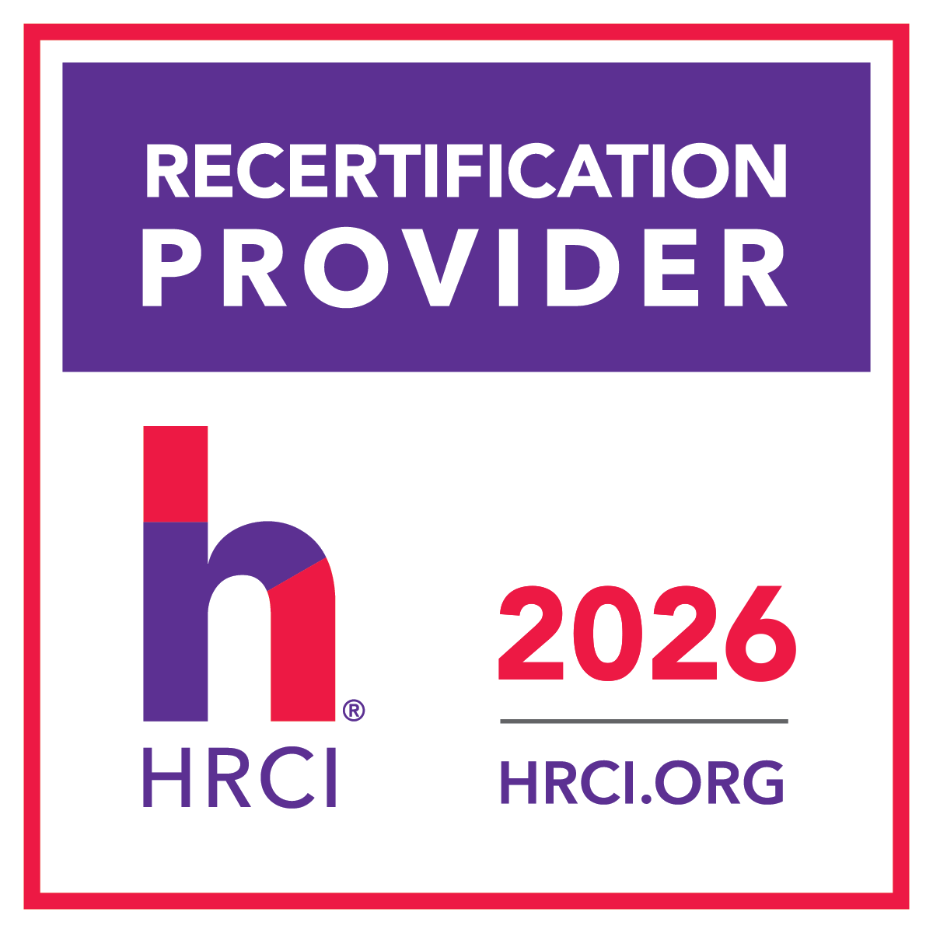
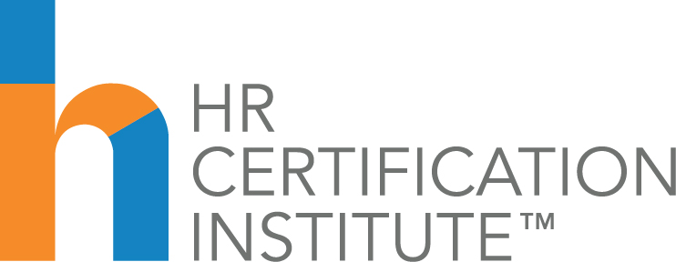

RECERTIFICATION CREDIT FORM

2026 KS SHRM Workforce Lunch & Learn Series
Webinar | March 31, 2026
“Encouraging Employee Use of AI in a Safe Space”
Artificial intelligence is quickly becoming a practical tool for everyday work—but many professionals are unsure where to start. This session introduces several accessible generative AI tools that can help office professionals improve productivity, streamline communication, and support everyday problem-solving.

Through live demonstrations and real-world examples, participants will learn how to use AI to draft communications, summarize information, organize ideas, and support routine business tasks. The session will also provide guidance on writing effective prompts and understanding where AI can add the most value in a professional setting.

Attendees will leave with practical examples, prompt strategies, and ready-to-use ideas they can immediately apply in their own role using free, widely available AI tools.

The use of this official seal confirms that this Activity has met HR Certification Institute’s® (HRCI®) criteria for recertification credit pre-approval. To earn recertification credit hours, please log the activity to your online recertification application at www.hrci.org.
This Program, ID No. 738592, has been approved for 1.0 HR (General) recertification credit hours toward aPHR™, aPHRi™ PHR®, PHRca®, SPHR®, GPHR®, PHRi™ and SPHRi™ recertification through HR Certification Institute® (HRCI®). Please make note of the activity ID number on your recertification application form. For more information about certification or recertification, please visit the HR Certification Institute website at www.hrci.org.

